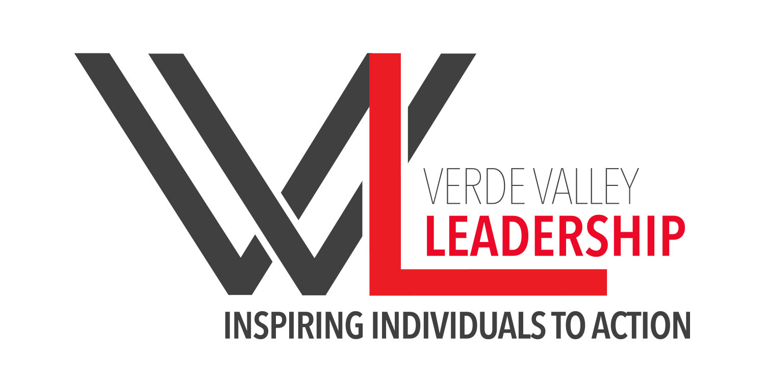
Application for Class XV

Please complete this application and mail in or e-mail by March 30th, 2020
along with a brief bio.
Please type or print the following:

1. Personal Information:
1.1 Name (Last, First, Middle Initial):

1.2 Nickname or your preferred name:

1.3 Length of residence in the Verde Valley:

1.4 Mailing Address (Street, City, State, Zip+4):

1.5 Physical Address (If different from above):

1.6 Primary Phone:

1.7 Secondary Phone:

1.8 Preferred Email address:

1.9 Spouse’s or Partner’s Name (if applicable):

2. Employer Information:
2.1 Employer:

2.2 Supervisor’s Name:

2.3 Employer / Supervisor’s Contact Information:

3. Personal References:
3.1 Name:
3.2 Phone:
3.3 Brief explanation of your relationship:

3.4 Name:
3.5 Phone:
3.6 Brief explanation of your relationship:

4. Participation & Employer Support

Do you have the full support of your employer for the time required to participate fully and effectively in Verde Valley Leadership? YES:_____ NO: ______

5. In the spaces provided below - or on separate pieces of paper as are necessary - please briefly respond to the following questions:
5.1 Describe the duties and responsibilities of your current job:

5.2 Describe your educational background:

5.3 In order of importance to you please list your community, civic, professional, religious, and/or social organizational membership/activity involvement:
5.4 Please describe any leadership roles you have held in the groups identified in 5.3 as well:

5.5 Identify two significant challenges we face in the Verde Valley. Why do you think these are significant community issues, and what do you see as possible solutions?
5.6 What do you hope to gain from being a part of Verde Valley Leadership?

5.7 How did you hear about the Verde Valley Leadership program? Did someone recommend you to VVL? If yes, please specify.

5.8 Do you have any criminal convictions? Yes: ______ No: _______
(Conviction will not necessarily disqualify an applicant from employment.)
If yes, please explain:

Thank you for your interest in Verde Valley Leadership.

Please email your completed application to info@vvleadership.org or send written application to:
VERDE VALLEY LEADERSHIP (VVL) P.O. Box 1663 Cottonwood, AZ 86326

Recruitment - Tricia Winters, vvlpresident@gmail.com (928) 593-0195

